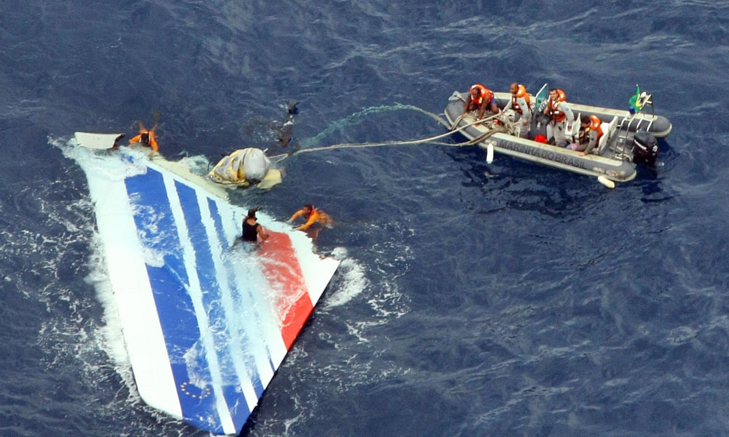

**Case Study: Responsibility of a Computing Professional**

**Submitted by:** Danica Marie A. Dumalagan

**Date Submitted:** May 12, 2023

### Brief overview

It was a scheduled international passenger flight from Rio de Janeiro, Brazil, to Paris, France. On June 1, 2009, the Airbus A330 serving the flight stalled and did not recover, eventually crashing into the Atlantic Ocean killing all 228 passengers and crew. The investigation resulted in a combination of human and technical factors that contributed to the crash.

### Investigation

Air France Flight 447 was a scheduled international passenger flight from Rio de Janeiro, Brazil, to Paris, France. On June 1, 2009, the Airbus A330 serving the flight stalled and did not recover, eventually crashing into the Atlantic Ocean killing all 228 passengers and crew [1]. The investigation by France's Bureau of Enquiry and Analysis for Civil Aviation Safety (BEA) concluded that the aircraft suffered temporary inconsistencies between the airspeed measurements—likely resulting from ice crystals obstructing the aircraft's pitot tubes —which caused the autopilot to disconnect. After which the crew reacted incorrectly and ultimately caused the aircraft to enter an aerodynamic stall, from which it did not recover [1]. Air France and Airbus were tried on charges of involuntary manslaughter for what was the worst plane crash in the French airline’s history [1].

On the 13th of October 2022, it was reported that the Paris Criminal Court had granted a request from plaintiffs to play the black box recordings of the Rio-Paris flight, Air France Flight 447, during the ongoing trial against Air France and Airbus. Data investigation revealed that the aircraft's speed sensors were broken, which is what led to the autopilot disengaging. The trial heard extensive detail from the final, fatal minutes in the cockpit as the confused captain and co-pilots fought to control the plane. As the plane approached the equator on its way to Paris, it had entered a so-called “intertropical convergence zone” that often produces volatile storms with heavy precipitation. As a storm buffeted the plane, ice crystals present at high altitudes had disabled the plane’s airspeed sensors, blocking speed and altitude information. The automatic pilot functions stopped working. The 205-tonne jet went into an aerodynamic stall and then plunged [3].

The factors that contributed to the Air France Flight 447 crash highlighted the complex interplay between automation and human decision-making, emphasizing the need for a balance between automation and manual flying skills and the importance of proper training for pilots and close regulation of aircraft design and maintenance.

### Who is responsible for it?

The article *"The Tragic Crash of Flight AF447 Shows the Unlikely but Catastrophic Consequences of Automation"* [2] published in the Harvard Business Review in 2017, provides a comprehensive review of the factors that contributed to the Air France Flight 447 crash in 2009, highlighting the complex interplay between automation and human decision-making, and how it can lead to catastrophic consequences. [2] argues that the reliance on automation in modern aircraft has led to a decrease in manual flying skills among pilots, making them ill-prepared to handle unexpected situations. This was evident in the Flight 447 incident, where the pilots' lack of understanding of the aircraft's systems and their over-reliance on automation led to a catastrophic failure. Moreover, [2] argues the deficiencies in the pilots' training that failed to equip them with the necessary skills to handle the specific scenario that unfolded during Flight 447. The incident emphasizes the importance of real-time flight data monitoring, and measures to be taken to improve the technology relevant to real-time mission-critical task, especially those that involves the safety of humans.

**Airbus** was responsible for designing and manufacturing the aircraft's systems, including the faulty pitot tubes, which led to the malfunctioning of the speed sensors and the autopilot disengaging. **Air France** was responsible for ensuring the aircraft's safety through proper maintenance and training of its pilots. However, the [2] argues that Air France had failed to provide adequate training to its pilots on how to handle emergency situations when automation fails.

The **pilots** also bear some responsibility, as they were unable to understand the aircraft's systems and failed to take appropriate action to regain control of the aircraft. The pilots' lack of manual flying skills and their over-reliance on automation contributed significantly to the incident. The **causal** responsibility of Airbus is evident in the pitot tubes' design flaw, leading to the malfunctioning speed sensors that caused the accident. Air France's **role** responsibility is evident in its failure to implement the recommended changes by Airbus and ensuring compliance with safety regulations. In terms of **legal** responsibility, both Airbus and Air France were charged with manslaughter by the French judiciary, with the trial held between 2019 and 2020. The French judiciary found Air France guilty of negligence in the crash.

### What could a computing professional do better?

The current systems rely heavily on automation, and in the case of Air France 447, this proved to be a fatal flaw. One possible improvement would be to incorporate more intuitive and user-friendly interfaces that enable pilots to quickly and effectively take control of the aircraft in emergency situations. Another possible improvement would be to integrate advanced sensor technologies that can detect and respond to changes in weather conditions and other factors that can affect flight safety. This could include improved pitot tubes that are less susceptible to icing or other environmental factors that can cause them to malfunction. Additionally, incorporating real-time monitoring systems that provide pilots with up-to-date information about weather conditions, air traffic, and other critical factors could help prevent accidents and improve overall safety. In addition to these technical improvements, it is also crucial for airlines and aviation authorities to prioritize safety and invest in comprehensive training programs for pilots and other personnel involved in the operation of aircraft. This should include training on manual flight control procedures, as well as effective communication and decision-making skills in emergency situations. Additionally, improving pilot training to better handle loss of control incidents and unexpected events using realistically designed flight and turbulence simulations to sharpen their emergency response skills while working with a very similar setup as that of an actual plane.

### References

[1] “Final minutes of Air France Flight AF447 to be examined as trial opens,” The Guardian, https://www.theguardian.com/world/2022/oct/10/air-france-flight-af477-2009-crash-trial-airbus (accessed May 12, 2023).

[2] “The tragic crash of Flight AF447 shows the unlikely but catastrophic consequences of automation,” Harvard Business Review, https://hbr.org/2017/09/the-tragic-crash-of-flight-af447-shows-the-unlikely-but-catastrophic-consequences-of-automation (accessed May 12, 2023).

[3] “Air Crash Investigation Air France Flight 447 crash,” YouTube, https://www.youtube.com/watch?v=LA-WeacusP4 (accessed May 12, 2023).

[4] Rfi, “Black Box Recording of deadly Rio-Paris flight to be played in court,” RFI, https://www.rfi.fr/en/france/20221013-black-box-recording-of-deadly-rio-paris-flight-to-be-played-in-court (accessed May 12, 2023).